Scenario Parameters
The parameters or settings of a scenario are only covered in this brief guide regarding Victory Conditions and Actions.
Because they are used to set conditions, the use of zones is covered first.

Zones
Hexes may be allocated as part of a zone.
There are 32 zones that may be used.
There is no limit to how many hexes may be in a zone (as long as there are enough hexes on the map!).
A hex may be designated multiple zones. e.g. a hex could be in zones 1, 5 and 12.
Zone hexes do not need to be adjacent to each other.
Set zones from the Edit, Zones… menu.
Select the zone number on the left of the screen and then click them into the hexes.
Hexes will only show their zone when that zone is selected on the left of the screen.
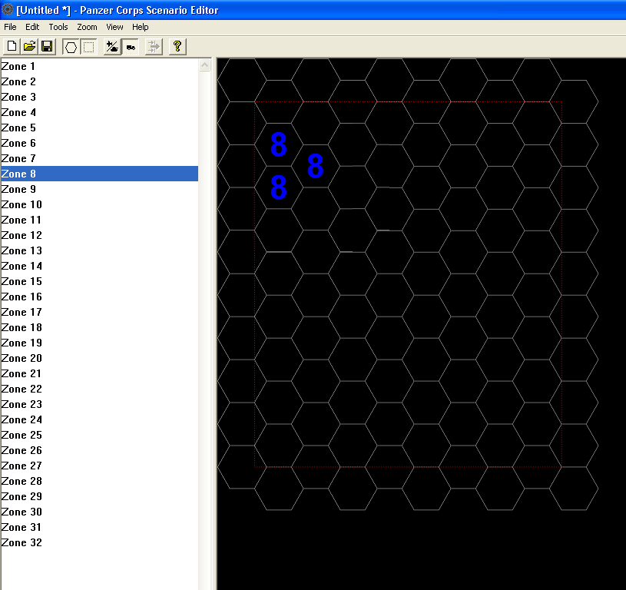
(This example has no terrain)

Victory Conditions (tab)

Introduction
Panzer Corps allows for a wide range of victory conditions from how many flags a player owns to how many turns have passed to specific conditions related to units, and many more. This section will not try to cover every condition but will give an overview of the possibilities.
To access the Victory Conditions: From the Edit, Unit Params…
Campaign conditions
Although there are five fields the campaign file (campaign.pzdat in the Panzer Corps\Data folder) recognises only the first 3. The other 2 are redundant at this point.
Outcomes: The normal Victory Conditions are Decisive Victory; Marginal Victory; and Loss. The strings in these fields appear on the result summary screen at the end of game and can be called whatever makes sense – Heroic Victory, Missed by that much! – whatever you think is appropriate.
Campaign branch: Not currently used. The campaign.pzdat determines which scenario will be played after this one depending on its outcome.
[Edit 20/08/2011]: I am yet to test this but I think this bit is incorrect. The Campaign Branch value will be 0, 1 or 2 where 0 = Decisive Victory, 1 = Marginal Victory, 2 = Loss. So, for example, a scenario could have 2 or even 3 conditions that will lead to one of these outcomes.
Score: not currently used.
Trigger: the condition that will cause the outcome. Triggers are covered later. Use the Edit… button to create or modify triggers.
Scenario conditions
As for campaign conditions, except all 5 outcomes can be used.
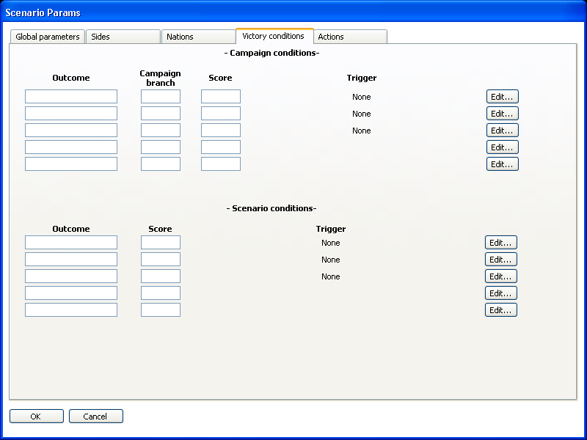

Actions (tab)
There are two types of actions that may be triggered here: a prestige action and/or a weather action.
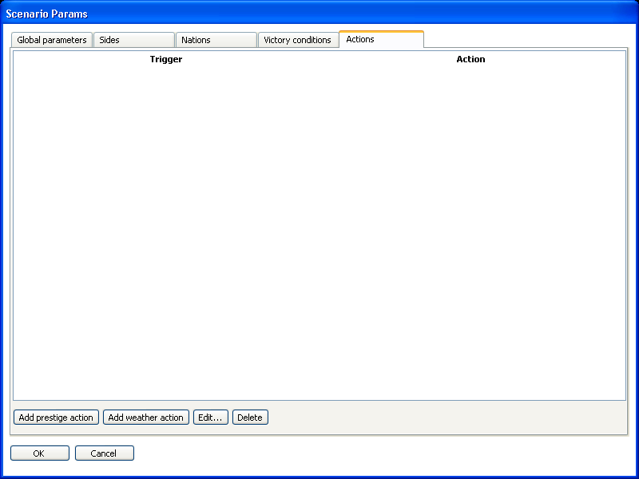

Prestige Action
A Prestige Action will add the prestige entered in the Axis and/or Allied fields of the dialog box. A negative value will deduct prestige from a player.
Examples:
- Player liberates Paris = +500 prestige (perhaps if Free French unit is the liberator)
- Player eliminates unit with name ‘Patton’ = +250 prestige
- Player controls 3 hexes in Zone 4 = +200 prestige
- Player loses unit with name ‘Manstein’ = -200 prestige
There are many, many more possibilities.
Use the Edit Trigger button to set the trigger conditions.
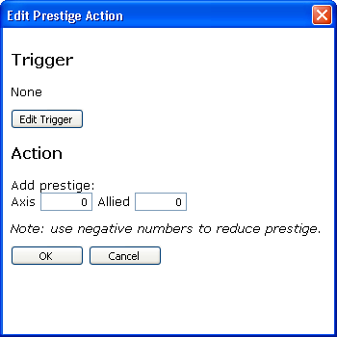

Weather Action
The weather can be set according to the turn or some other condition. This may be particularly useful for historical scenarios e.g. Wacht am Rhein should probably occur with lots of snow in the early turns. Weather conditions can be affected by map conditions (units and flags), too, but this may be less useful.
Weather is clear unless one of the other types of weather occur. The fields in the dialog box set the percentage chance of a type of weather occurring.
There is no setting for mud – this is set by the moisture in the Global parameters tab of the scenario.
Examples:
- Turns 1-5 of a scenario are always to be snow: Snow 100%
- There is a 50% chance of rain on Turn 5: Turn trigger: 5; Weather action Rain 50%
- 30% Rain; 20% Snow; 10% Overcast = (100-30+20+10) 40% Clear.
Again, the possibilities are great.
Use the Edit Trigger button to set the trigger conditions.
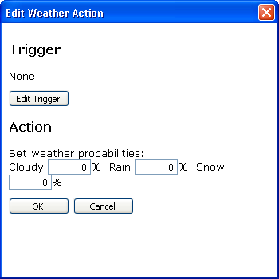

Triggers
Triggers are conditions that activate actions. As the dialog box says, when all the conditions of the trigger are met, the action (Victory condition, prestige or weather action etc) will occur.
Triggers are based on time conditions and/or map conditions. These are described below.
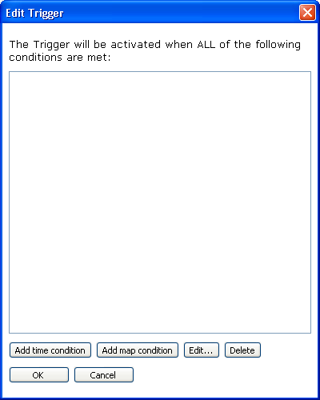

Conditions

Time condition
Time conditions affect what happens in designated turns. As the note says on the dialog box, turns are counted from the end of the scenario. For a condition that fires on the final turn of the scenario set both field values to -1.
NB: You need to delete the entry in the field first and then enter -1 from the keyboard.
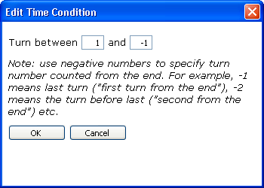

Map conditions
A map condition is a condition that is triggered when a certain criteria is met that relate to flags owned and/or units.
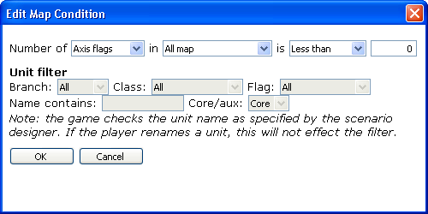
Flags and units:
‘Flags’ refers to hexes with a flag in them (logical!). Most flags will have a national flag such as Germany, UK etc. but a blank or Neutral flag is one that is currently not owned by either side. It cannot be used for supply or transport. (You may see this happen when a strategic bomber ‘neutralises’ a flag). In conditions, flags may be filtered by side (Axis or Allied) and by nationality (Hungary, France, USSR etc.)
Number of: Axis flags, Allied flags, Neutral flags, Axis units, Allied units
in: All map, Primary objectives, Secondary objectives, Zones (1-32)
is: Less than, No more than, Equal to, No less than, More than
Unit filter:
The Unit filter will check to see if conditions related to units on the map are being met.
Most scenarios have a flags-owned trigger but some have conditions based on units, such as Operation Huntress, which requires that the Panther with the name ‘Panther Prototype’ reaches a zone (1) hex on the edge of the map. The unit filter is only looking for the word ‘prototype’. This filter is based on what the designer designates as the unit name, not what the player calls it. So, even if a player changed the name of the Panther to something else the scenario would still recognise it as ‘Panther Prototype’.
There are a number of criteria or parts to the unit filter.
Branch: Ground, Air, Naval
Class: select from available unit classes (Tank, Recon, Artillery etc.)
Flag: nation flags
Name contains: a string to search for in a unit’s name as set by the designer (not the player)
Core/aux: whether to search for Core units, Auxiliary units or both
Example:
An easy one to start:
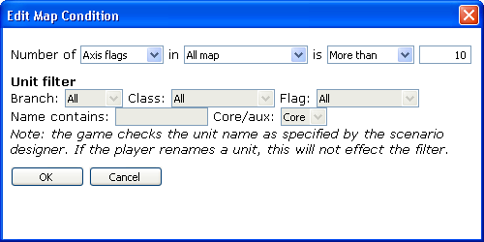
Explanation: this condition will be met if the number of flags (Primary or Secondary – see below) owned by the Axis player exceeds 10.
A bit more complex:
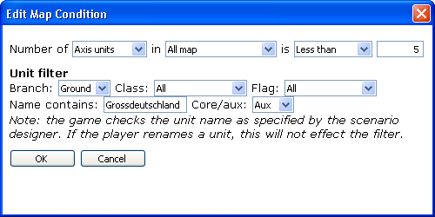
Explanation: this condition will be met if the Axis player has less than 5 ground units originally designated as from Grossdeutschland in his auxiliary unit list.
Using zones:
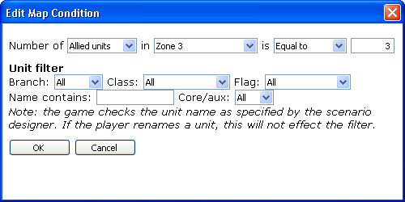
Explanation: this condition will be met if there are exactly 3 Allied units of any type in hexes belonging to Zone 3.
Primary Objective hexes:
Primary hexes are set by adding a Special Flag (the gold hexagon) to a hex that already has a flag.
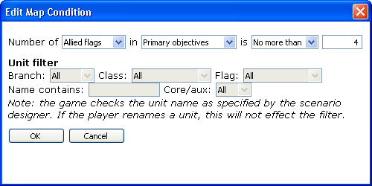
Explanation: this condition is met if the Allied player owns 1, 2, 3 or 4 Primary Objective hexes.
Secondary Objective hexes:
Secondary objective hexes are ones that have a flag but have not been designated as Primary Objectives (see above).
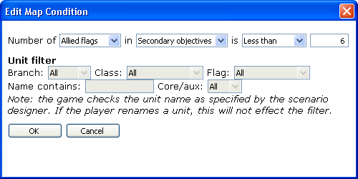
Explanation: this condition will be met if the Allied player owns less than 6 secondary objective hexes.
Last one:
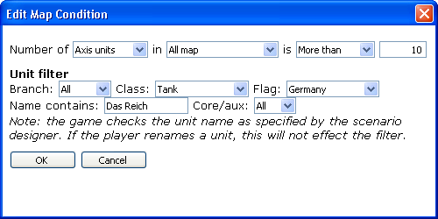
Explanation: this condition will be met if the Axis player has more than 10 German tanks, designated with the name ‘Das Reich’ in his Core and Auxiliary unit lists.

Tips
- Check for overlapping victory conditions. e.g. If Turn 5 is covered in two types of conditions it will fire the top one.
- Conditions are checked top to bottom on the list.
- Remember that not all zones can be seen in the Scenario Editor at once; only the selected zone will display at one time.
- Test, test and test again.

